**Computer Vision HW8**

R08922a27 資工系 人工智慧碩士班 李吉昌

I use python 3.7 to implement all image processing requirements. Reading .bmp file by **PIL**, and then processing through **NumPy** array.

* **1. Results**

**Gaussian noise with amplitude of 10**

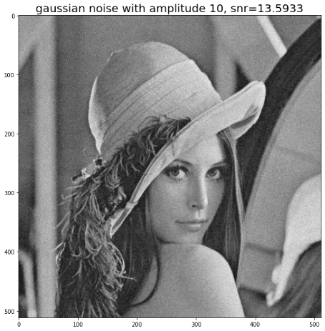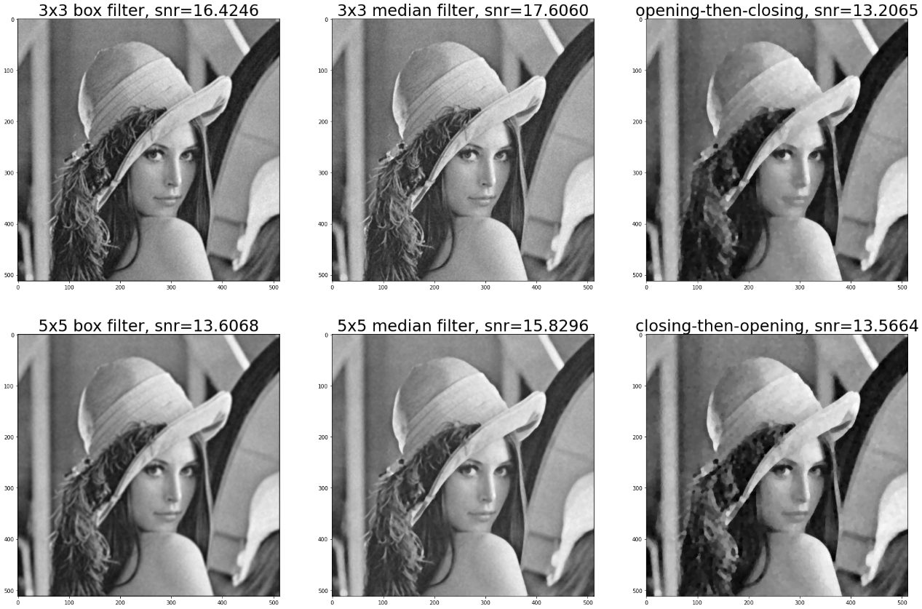

**Gaussian noise with amplitude of 30**

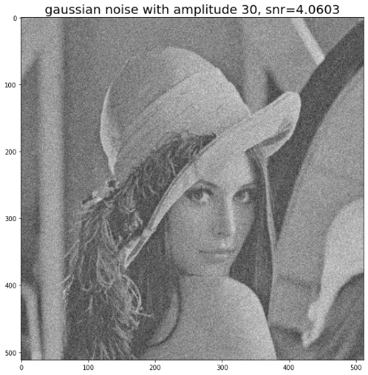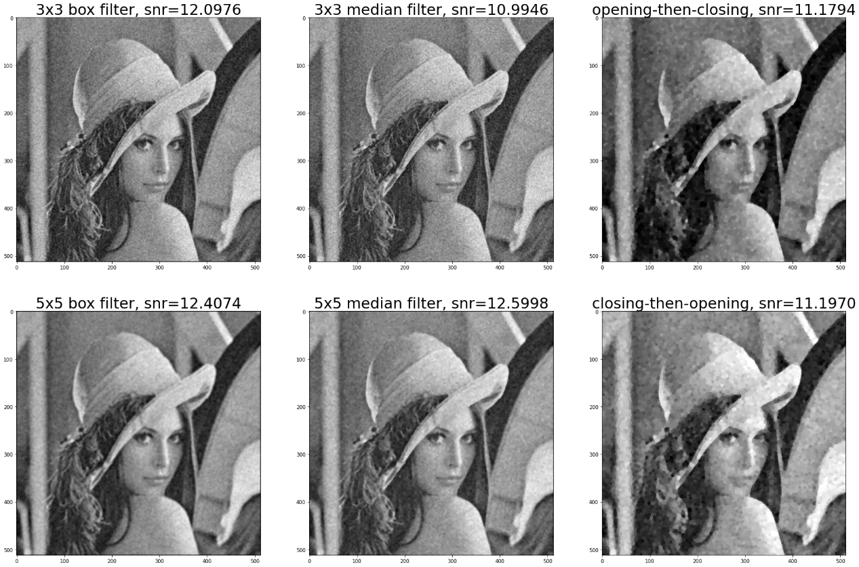

**Salt-and-Pepper noise with probability 0.1**

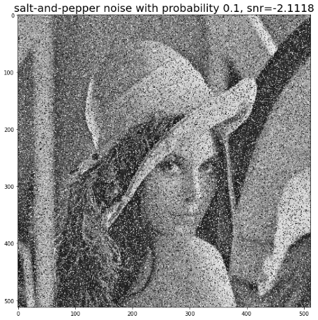

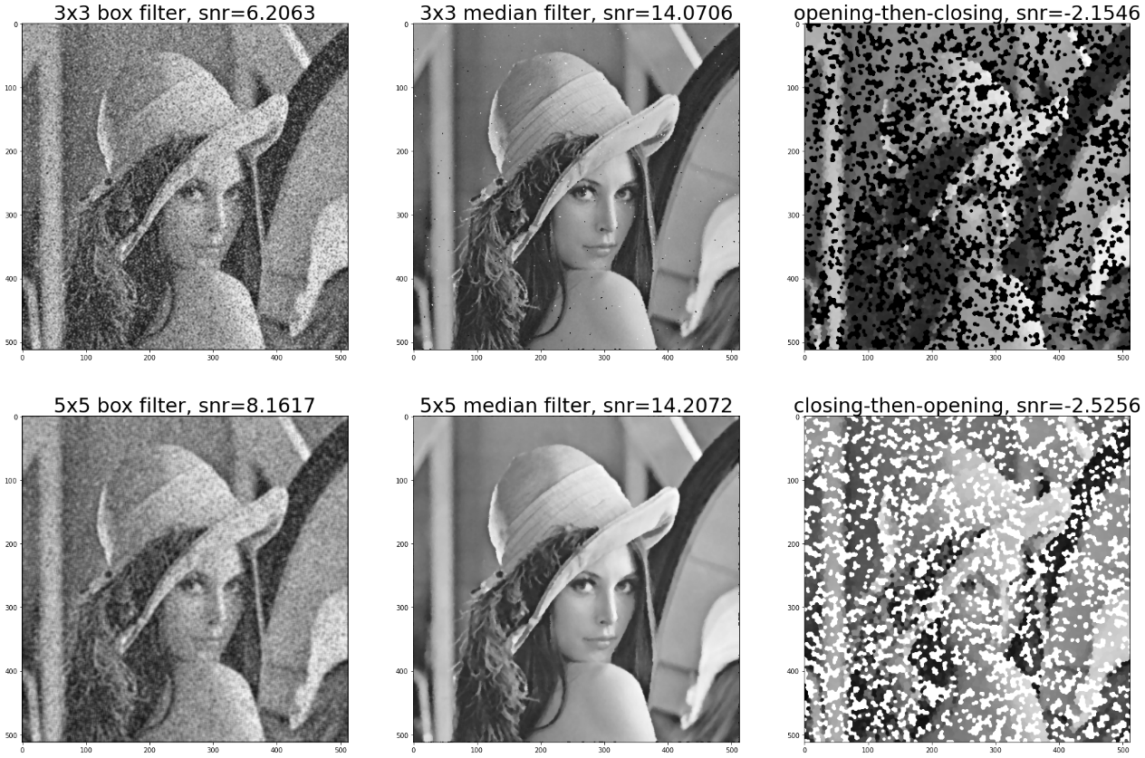

**Salt-and-Pepper noise with probability 0.05**

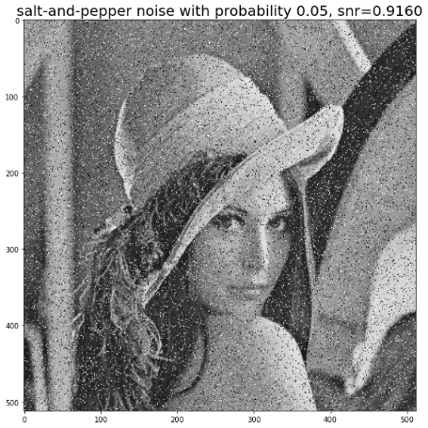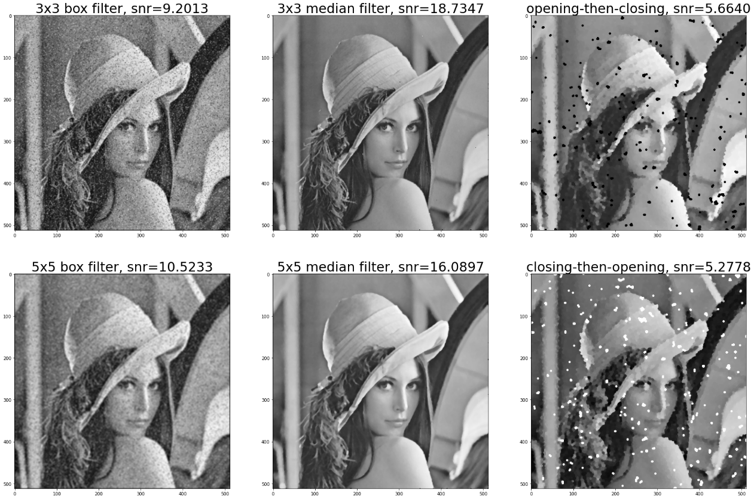

* **2. Code fragment**

def gaussian_noise_transform(img, amp):

return img + amp * np.random.normal(0, 1, img.shape)

def salt_and_pepper_noise_transform(img, thr):

prob_map = np.random.uniform(0, 1, img.shape)

salt_idx = prob_map > 1 - thr

pepper_idx = prob_map < thr

img_sp = img.copy()

img_sp[salt_idx] = 255

img_sp[pepper_idx] = 0

return img_sp

def padding(img, filter_size):

img_pad = np.zeros((img.shape[0] + filter_size // 2 * 2, img.shape[1] + filter_size // 2 * 2), np.int)

for i in np.arange(filter_size // 2, img.shape[0] + filter_size // 2):

for j in np.arange(filter_size // 2, img.shape[1] + filter_size // 2):

img_pad[i, j] = img[i - filter_size // 2, j - filter_size // 2]

return img_pad

def box_filter(img, filter_size):

img_mean = np.zeros(img.shape)

img_pad = padding(img, filter_size)

for i in range(img_mean.shape[0]):

for j in range(img_mean.shape[1]):

img_mean[i, j] = img_pad[i: i + filter_size, j: j + filter_size].mean()

return img_mean

def median_filter(img, filter_size):

img_med = np.zeros(img.shape)

img_pad = padding(img, filter_size)

for i in range(img_med.shape[0]):

for j in range(img_med.shape[1]):

img_med[i, j] = np.median(img_pad[i: i + filter_size, j: j + filter_size])

return img_med

def snr(img_org, img_pro):

noise = img_pro - img_org

return np.log10(img_org.var()/noise.var()) * 10

* **3. Brief Description**

All the assigned operators' implementation details follow the course's lecture slides. The **np.random** was used to simulate all the assigned noise distribution.The filters were implemented by using looping to determine each processed pixel's value. Please note that the boundary pixel's values of the opening and closing operation's outputs are different, so that the SNR values would be a little different from the reference.